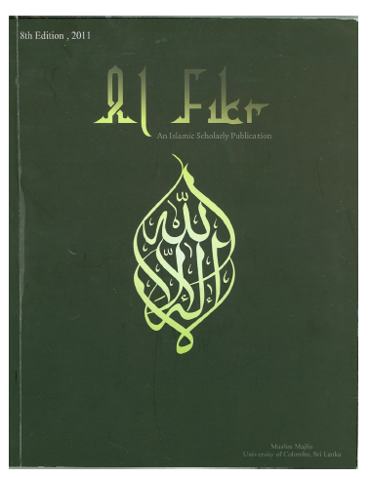

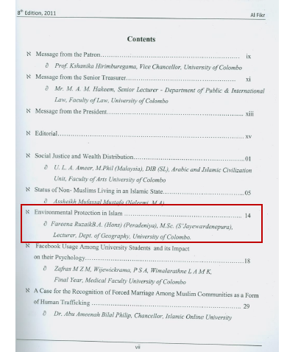

ISLAMIC PERSPECTIVE OF ENVIRONMENTAL PROTECTION
by
Fareena Ruzaik
B.A. (Hons) (Peradeniya), M.Sc. (S’Jayewardenepura)
Lecture - Dept. of Geography, University of Colombo
Islam provides a complete way of life for every mankind in this Universe. It is a divine guidance from Almighty Allah, the creator of this Universe. It covers all the things people do in their life time. It shows us the best way to conduct our private and public affaires, elaborating a person’s duties towards his Creator (Hakkulah) and to others (Hukukul Ibadath). Therefore, every human being must act according to it and are answerable for each and every action of them on the Day of Judgment. Man, as the best creation of this world and the trustee of the earth, has great responsibilities and accountabilities towards nature. The resources have been given to mankind to use for their day to day needs without compromising to the environment and human lives. It is followed by either reward or punishment based on their behavior. This is clearly mentioned both in the Quran and Sunnah.
The countries in the world struggle to protect and conserve the environment for the betterment of future generations. The population growth, infrastructure developments, industrializations, agricultural activities, urbanization etc. are interconnected, but are contrasting elements in the context of environmental conservations. As there are no alternatives, balancing of these activities is a vital role of Policy Makers. In this point of view, the environmental consciousness became the center point of the economic development activities since 1970s.
.
In the early 1970s, the concept of “sustainable development” became a common theme as concerns grew over the burgeoning world population and increasingly polluted environment. One of the turning points of sustainable development was the United Nation’s Conference on “Human Environment” in Stockholm in 1972. The Brundtland Report (1987) of the World Commission on Environment and Development characterized sustainable development as “development that meets the needs of the present without compromising the ability of the future generation to meet their own needs”. The term “sustainable development” was further popularized by the Rio Summit on environment and development in 1992, which approved the action program, Agenda 21, under which world governments agreed to promote sustainable development nationally and in international co- operation. (Asia and Pacific Forestry Commission (2000).

However, all the countries failed to provide constant solutions or an appropriate management system to tackle this problem in an effective manner. But, Islam provided various disciplines and guidance pertaining to the nature and environmental protections 1400 year ago. The main causes for environmental degradation are human activities and natural process. Islam concentrates to extend various controlling measures on mankind because they are the originator of these issues. Self-control is one of the main qualities of Islam. It discourages self indulgence, lavish living and wastage. The people those who had such life style in the past were destroyed by Almighty Allah. The Quran says in Sura Al- Isra 17:16.

“When we resolve to annihilate a town, we first command those that live in luxury (to obey Us). But, they transgress therein. Thus, the sentence is justly pronounced against it and we utterly destroyed it.”

Accordingly, unlimited and excessive indulgences of mankind in any form will cause incalculable damages to our surroundings. As a care taker of this earth, it is every ones prime and moral duty to preserve the environment in which we dwell, to safeguard environmental balance. Every renewable and non-renewable resources of this earth had been created by Almighty with different purposes and to maintain natural balance of this earth. The holly Quran reveals in verse 15: 19.

“And the earth we have spread out, set upon it mountains firm and immovable, and produced therein all kinds of things in due balance."

In reality, Himalayan Peak has a height of nearly 8,932 meters while Mariana Trench has a depth of more than 11,000 meters. This is one of the clear evidence of how Allmighty Allah has balanced this earth. It is scientifically proved that if natural balance is disturbed; we will have to be faced serious consequences. The earth and its countless bounties have been created for mankind to use, without abuse or misuse. The circle of naturally available blessings for the benefit of humanity has to be kept alive for all generations to come in the future. Almighty has created all the living and non-living things in this Universe according to a system.

“That has created pairs in all things……… (43:12-14)

This Holy Quran verse reveals that all creations in this world had been created in pairs for the enrichment of eco-system. Male and female, day and night, hills and valley, sun and moon, cool and hot etc are some example for such creations. These environmental elements are needed for the survival of mankind subjected to control of Almighty. Therefore, the primary reason for highlighting the temporality of things is to remind people to focus upon the non-permanent character of human existence on this earth. It is hoped that once people are conscientious of the limitation of life, they will behave in a positive and constructive way. As a result, it is anticipated that the environment itself will benefit from the proper behavior of people.

"He has made the Night and the Day, and the Sun and the Moon, and the Stars, subservient to you by His command: Surely in this are Signs for people who are wise." (Quran:16:12).

The subjection of the elements that make up the environment is spoken of in many chapters of the Holy Quran.

"It is He who has subjected to you the Ocean, so that you may eat of its fresh fish and bring up from it ornaments with which to adorn your persons. And you see the ships ploughing their course through it. (All this He has created) that you may seek and render thanks to him….. (16:14).

Two third of earth surface is covered with water (fresh and salt water). Why has God Almighty created sea water salty along with its great waves? Mostly, Industrial, domestic and other forms of waste are dumped into the sea from all around the world. If these wastes are disposed in to the fresh water, living things will have an unpleasant surrounding where they are unable to survive. Therefore, it is very clear salt water purifies wastes and provides a healthy environment and the waves play a major role in this purification process. Further, Mangroos grows along the coast which are specific to the coastal zone. The places where these species have been depleted have largely affected by 26th December 2004 Tsunamy attack, killing more than 50,000 lives in coastal belt of Sri Lanka. All creations of Almighty have a purpose behind it. If nature is disturbed by human activities, it will result serious and uncountable calamity to the environment.

Mankind, as trustee of the earth and vice regent has great responsibilities and accountability towards the nature. If the cosmic order is preserved in good order, human beings are better off and if they interfere adversely with such natural order of things, punishment shall surely follow. The Quran further says about the preservation of environment.

"Then we made you heirs in the land after them, to see how you would behave!" Quran, 10:14

These definite commandments of the Quran make it clear that the Islamic perspectives of mankind’s vice regency on earth forms a test which includes how human beings relate to the environment. As a woman and mother, we have a great role in bringing up our children to become an environmentally conscious and disciplinary person in the society. We teach our kids about the dangers of fire using infant language. Even two years old infant is nervous on touching fire. Like wise, importance of cleanliness, systematic behaviors and discipline should be taught from their childhood. Such practices will result a good future generation.

Islam provides guidance for straight path and injunctions against human misconduct and miss utilization of nature. Numerous quotations from the Quran about harnessing the natural elements could be extracted for the adjustment of human’s bad conducts. It is also clear that the exploitation of nature and its resources will lead to the depletion of natural heritage of mankind. It is essential to maintain the natural equilibrium which is to be kept up. The Quran emphasizes that those who did not obey these natural laws will be harmed by nature. Therefore, trusteeship and vice regent to oversee the affairs of its earthly existence has to be faithfully executed. Accordingly, above factors provide us with the fundamental philosophy of Islamic provisions of the earth’s eco-system and its conceptions relating to the environment protection.

References

1. Fazlun M. Khalid (2002), “ Sustainable Development and Environmental
Collapse, An Islamic Perspective, National Awqaf Foundation of South Africa.

- Hasan, Zubair (2006), “Sustainable development from an Islamic Perspective:
meaning implications and policy concerns, International Islamic University of Malaysia.

- Professor Dr. Farooq Hassan (2006), “Islam: Environmental Protection”, Karachi, Pakistan.

4. J:\Islam + envit\Islamic perspective on going green.htm

